**Source is fictional**

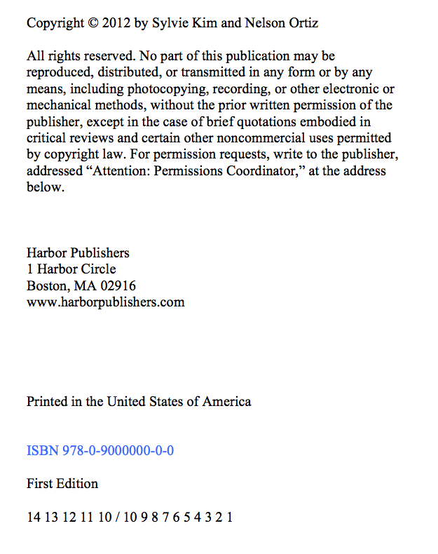

Volunteering:

Be the Best You Can Be

Sylvie Kim and Nelson Ortiz

Harbor Publishers